Create a windows Vm machine in AWS and connect with RDP open CMD in windows share the about system info.

Create a Windows EC2 Instance and Connect Using RDP

EC2 stands for Elastic Compute Cloud. EC2 is an on-demand computing service on the AWS cloud platform. Under computing, it includes all the services a computing device can offer to you along with the flexibility of a virtual environment. In this article, we will see how to create an EC2 instance on AWS and how we can access that instance using RDP applications.

Step 1 - Search for EC2 in Services.

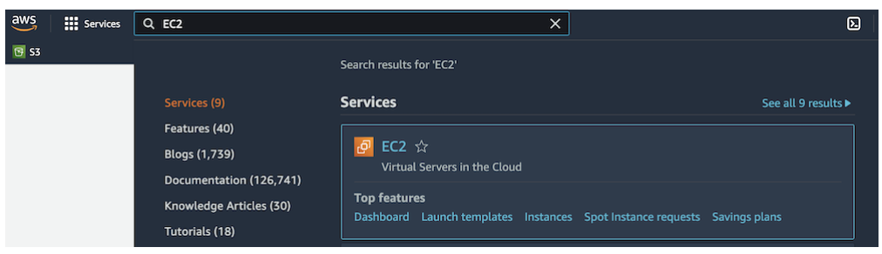

Step 2 - Click on Launch Instance.

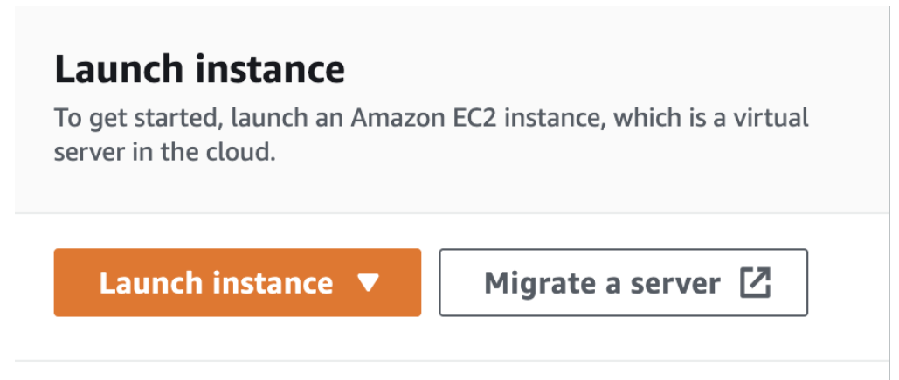

Step 3 - Now we will fill in the configurations for creating an EC2 Instance. Give a name to your Instance or remain its default. Then select the Windows AMI (Amazon machine Image). We are selecting Microsoft Windows server 2022 base.

Now select the Instance type.

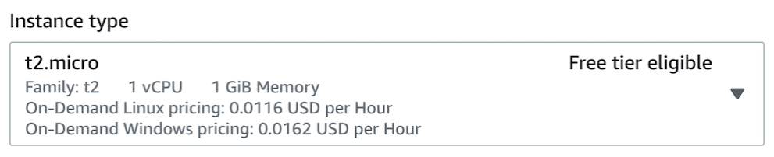

Select the key pair or create your own by clicking on Create new Key pair.

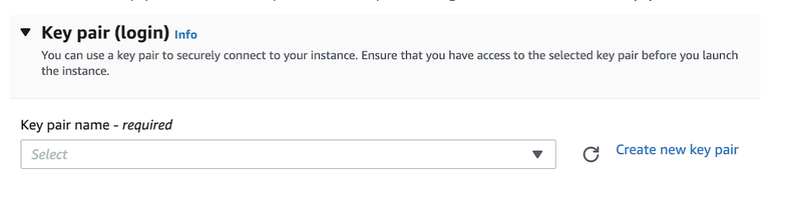

In the Network setting, make sure RDP traffic is allowed.

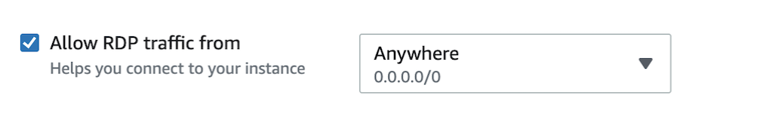

Set your storage up to your need. Now we are ready to launch our instance by clicking on Launch Instance on the right side.



After some time your instance will be ready and in next step, we are ready to connect with our EC2 instance using RDP Client application.

Step 4 - The First download and install RDP client app to your instance list, select your instance and click on Connect. There are three ways to connect to the instance, click on RDP Client.

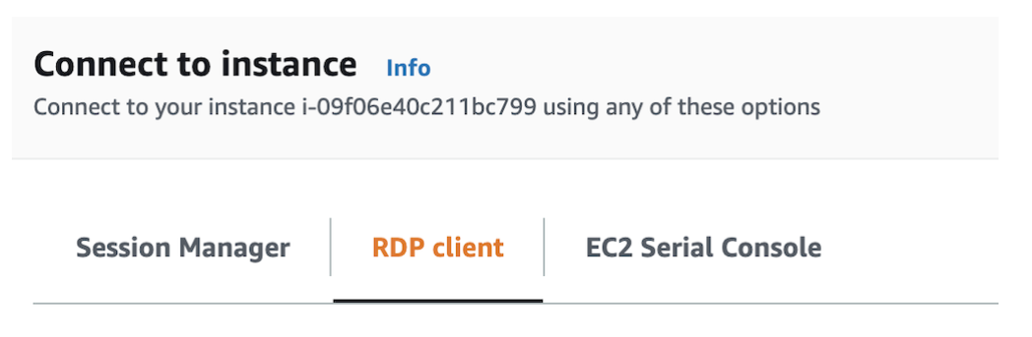

Now click on Download remote desktop file.



We also need a password to connect for that, click on Get Password and browse your key pair and click on Decrypt Password. After this, your password will be shown on the screen, copy it and save it somewhere.

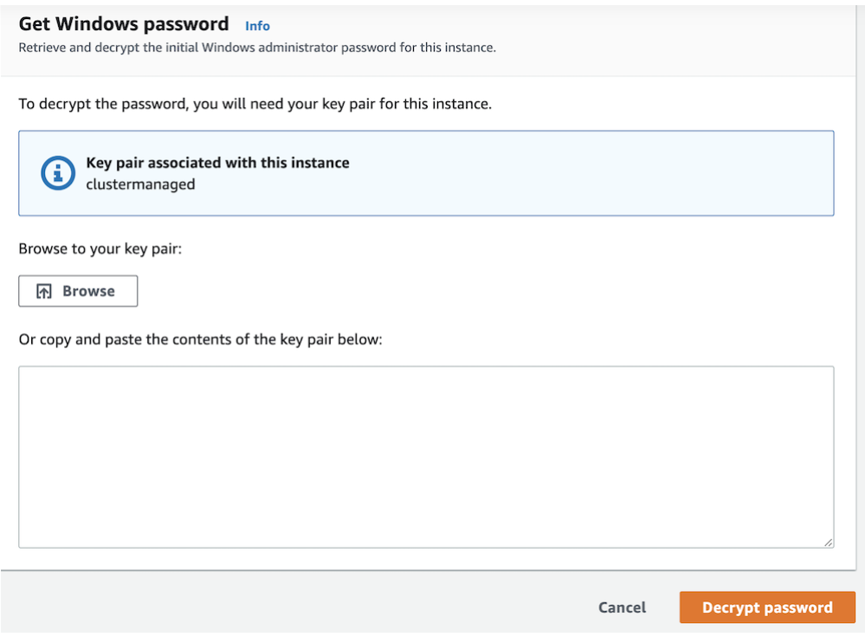

Now double-click on the remote desktop file you downloaded earlier. Paste the password and press Continue. (If your RDP connection client application asks you for a username, type Administrator.)

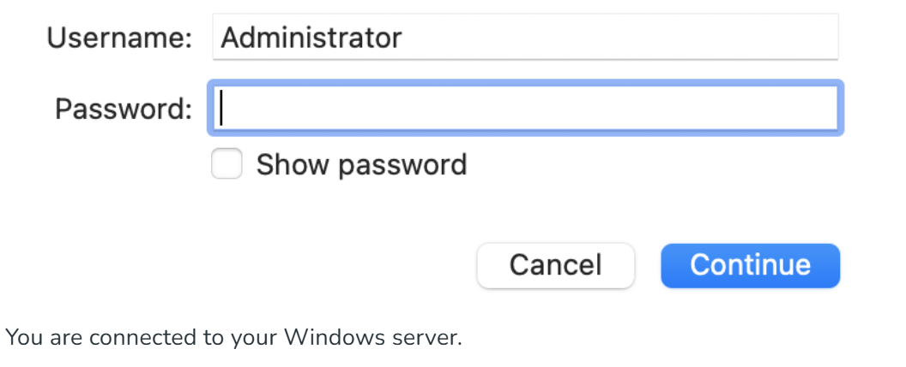

Microsoft Azure - Connecting Windows VM using RDP

Step 1: First, head over to the Virtual Machine that you want to connect to.

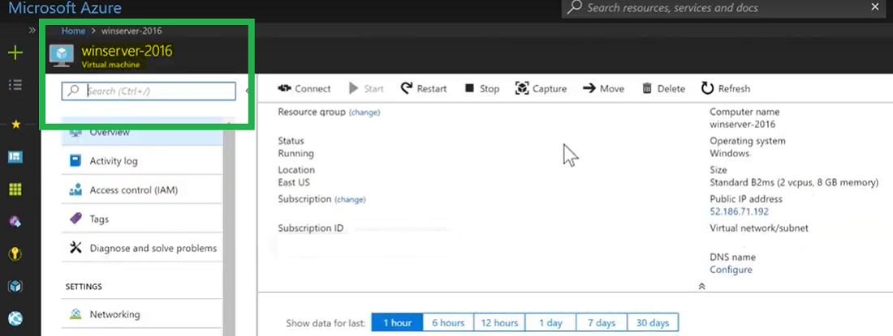

Step 2: Now in the top navigation bar, we need to hit the "Connect Button".

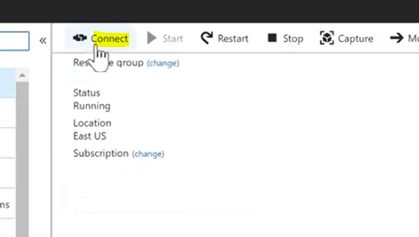

What this will do is have you download an RDP file. We'll save this on the desktop.

Step 3: Now open the "File", and hit "Connect".

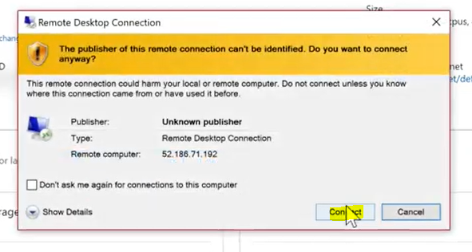

Step 4: Now we have to make sure that we use the correct account, and we have to put in our password.

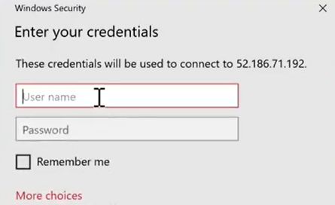

Step 5: Then go ahead and accept the certificate for the connection, and at no time at all, we'll be connected to our Virtual Machine.

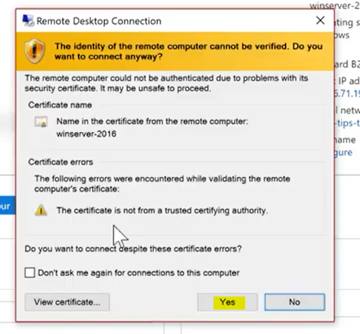

Connect to your Windows instance

The following procedure uses the Remote Desktop Connection client for Windows (MSTSC). If you're using a different RDP client, download the RDP file and then see the documentation for the RDP client for the steps to establish the RDP connection.
To connect to a Windows instance using an RDP client

On the Connect to instance page, choose Download remote desktop file. When the file download is finished, choose Cancel to return to the Instances page. The RDP file is downloaded to your Downloads folder.

Run mstsc.exe to open the RDP client.

Expand Show options, choose Open, and select the .rdp file from your Downloads folder.

By default, Computer is the public IPv4 DNS name of the instance and User name is the administrator account. To connect to the instance using IPv6 instead, replace the public IPv4 DNS name of the instance with its IPv6 address. Review the default settings and change them as needed.

Choose Connect. If you receive a warning that the publisher of the remote connection is unknown, choose Connect to continue.

Enter the password that you saved previously, and then choose OK.

Due to the nature of self-signed certificates, you might get a warning that the security certificate could not be authenticated. Do one of the following:

If you trust the certificate, choose Yes to connect to your instance.

[Windows] Before you proceed, compare the thumbprint of the certificate with the value in the system log to confirm the identity of the remote computer. Choose View certificate and then choose Thumbprint from the Details tab. Compare this value to the value of RDPCERTIFICATE-THUMBPRINT in Actions, Monitor and troubleshoot, Get system log.

[Mac OS X] Before you proceed, compare the fingerprint of the certificate with the value in the system log to confirm the identity of the remote computer. Choose Show Certificate, expand Details, and choose SHA1 Fingerprints. Compare this value to the value of RDPCERTIFICATE-THUMBPRINT in Actions, Monitor and troubleshoot, Get system log.

If the RDP connection is successful, the RDP client displays the Windows login screen and then the Windows desktop. If you receive an error message instead, see Remote Desktop can't connect to the remote computer. When you are finished with the RDP connection, you can close the RDP client.

Configure user accounts

After you connect to your instance over RDP, we recommend that you perform the following tasks:

Change the administrator password from the default value. You can change the password while you are logged on to the instance itself, just as you would on any computer running Windows Server.

Create another user with administrator privileges on the instance. This is a safeguard in case you forget the administrator password or have a problem with the administrator account. The new user must have permission to access the instance remotely. Open System Properties by right-clicking on the This PC icon on your Windows desktop or File Explorer and selecting Properties. Choose Remote settings, and choose Select Users to add the user to the Remote Desktop Users group.

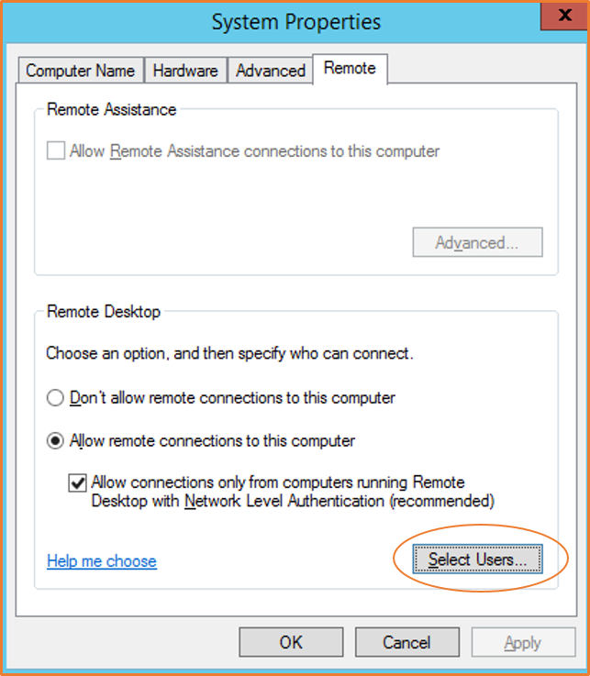

Part 1: Create a Windows VM (EC2 Instance) in AWS

Sign in to the AWS Management Console and navigate to the EC2 dashboard by searching for "EC2" in the services menu.

Launch an Instance: Click on the Launch instance button.

Configure Instance Details:

Name: Give your instance a name (e.g., "WindowsVM").

Application and OS Images (AMI): Select a Microsoft Windows Server AMI (e.g., Microsoft Windows Server 2022 Base), ensuring it is marked as "Free tier eligible" if applicable.

Instance type: Choose a free tier eligible type like t2.micro.

Key pair (login): Choose an existing key pair or click Create new key pair. Download the .pem file and save it securely; you will need this to decrypt the administrator password later.

Network settings: Ensure the security group rules allow RDP traffic (Port 3389) from your IP address or anywhere.

Configure storage: Use the default storage settings (usually 30 GB in the free tier) or adjust as needed.

Launch the Instance: Click the Launch instance button. The instance status will initially be "pending" and change to "running" after a few minutes.

Part 2: Connect with RDP and Open CMD

Select Instance: In the EC2 Instances list, select your running Windows instance.

Connect: Click the Connect button at the top of the console.

RDP Client Tab: Select the RDP client tab.

Get Password: Click Get password. You will be prompted to upload the .pem private key file you downloaded earlier. Upload the file and click Decrypt password to reveal the default administrator password. Copy this password.

Download RDP File: Click Download remote desktop file and open the downloaded .rdp file on your local machine.
Connect via RDP:

When the Remote Desktop Connection application opens, the public IP/DNS of your VM should be pre-filled.
Click Connect.

When prompted for credentials, the username is typically Administrator. Paste the decrypted password.

Accept any certificate prompts to connect to the Windows server desktop.
Open CMD: Once the Windows desktop appears, press the Windows key, type cmd, and press Enter to open the Command Prompt

Part 3: Get System Information and Share

Run Command: In the CMD window, type the following command and press Enter:

systeminfo

This will display detailed system information about your Windows VM.

Copy Information: Select the output text in the CMD window (right-click and select Mark, then select the text and press Enter to copy) or right-click the title bar, select Edit > Select All, then press Enter.

Share on GeeksforGeeks:

Navigate to the GeeksforGeeks forum or community page (you may need to search for a relevant forum or a Q&A section, as specific community features are not explicitly detailed in the search results).

Create a new post or reply to a relevant thread.

Paste the copied system information into your post, potentially adding context about the AWS EC2 instance you created.

